INFORMATION SHEET – RENT REVIEWS
Rent reviews are dealt with in Part 5, Division 3 of the Retail Leases Act 2003 (the Act). This information sheet is intended to provide assistance and to be as accurate and informative as possible – but is necessarily directed to general questions and is therefore not a substitute for legal advice.
Information provided in this information sheet applies to retail premises to which the Act applies. Please refer to the Information Sheet ‘What are Retail Premises?’ published by the Victorian Small Business Commission (VSBC) for guidance as to whether leased premises are covered by the Act.
What is a rent review?
A rent review is a review of the rent payable under a retail premises lease where the landlord and tenant have agreed in a lease for the rent to be reviewed.
If a lease provides for a rent review during a tenancy, the details will most likely be in an attached Schedule to the lease and they must state:
- when the review is to take place; and
- the basis or formula on which the reviews are to be made.
Under the Act, a rent review must be made on the basis of one of the following five methods:
- a fixed percentage – for example 2% each year;
- an independently published index of prices or wages such as the Consumer Price Index;
- a fixed annual amount – for example $4000 per year;
- the current market rent of the retail premises – discussed in further detail below; or
- a basis or formula prescribed by the regulations – none have been prescribed at this time.
These reviews are to be conducted, and changes applied as early as practicable within the time provided by the lease. If the landlord has not initiated the review within 90 days after the end of that time, the tenant may initiate the review.
What if a lease does not state how a rent review is to be made?
A rent review provision in a lease will be void if the lease does not specify how the review is to be made. In such a case, or where the lease fails to specify only one of the methods listed above at (a) to (e), the rent can be set at an amount as agreed between both landlord and tenant.
If the landlord and tenant then fail to reach an agreement, the following process applies:
- Either party is to give the other a written notice specifying the amount of rent sought;
- If there is no agreement within 30 days of a notice being given, the amount of current market rent will be determined by a Specialist Retail Valuer (SRV) appointed by the VSBC.
What is the current market rent of the premises?
The current market rent is taken to be the rent obtainable at the time of the review in a free and open market between a willing landlord and a willing tenant, in an arm’s length transaction, having regard to the following matters:
- the provisions of the lease;
- the rent that would reasonably be expected to be paid for the premises if they were unoccupied and offered for lease for the same, or a substantially similar, use to which the premises may be put under the lease;
- the landlord’s outgoings to the extent to which the tenant is liable to contribute to those outgoings;
- rent concessions and other benefits offered to prospective tenants of occupied retail premises.
The current market rent is not to take into account the goodwill created by the tenant’s occupation or the value of the tenant’s fixtures and fittings.
If a lease provides for a market rent review, the parties are to attempt to agree on an amount having regard to the above factors.
What if the parties cannot agree on current market rent?
If a tenant and landlord fail to agree on what the current market rent is - it is to be determined by a valuation carried out by an SRV - defined in the Act as a Valuer having not less than 5 years’ experience in valuing retail premises.
The parties are to first attempt to agree on an SRV to undertake this valuation. If they can come to an agreement the valuation fees are to be split equally between the landlord and the tenant. If the parties fail to agree on an SRV to be used, they can request that the VSBC appoint an independent SRV, with the fees to be paid by the parties in equal shares.
Either party can submit an application to the VSBC to request that an SRV be appointed to determine the market rent. This will apply even if the lease provides for a rent to apply where the tenant has not objected to a notice of rent increase within a specified time. As part of this application, the parties will need to provide a copy of the lease for the premises, and written evidence of the parties’ failure to agree on a Valuer. Often, parties provide copies of emails or letters showing that the parties cannot agree on a Valuer.
How does the VSBC appoint an SRV?
Once the VSBC receives the application and appropriate evidence, an officer appointed by the VSBC will then liaise with either the Australian Property Institute (API) or the Real Estate Institute of Victoria (REIV) to seek nominations for an appropriate SRV who has the necessary experience and does not have a conflict of interest with either party.
Once the nomination has been received, the VSBC will provide the SRV with the details of the parties and the parties with the details of the SRV so that they can arrange for the Valuer’s terms of engagement to be signed.
How is the determination made by an SRV?
The VSBC formally appoints the SRV to undertake the valuation. From the date of accepting the formal appointment, the SRV has 45 days to complete the valuation, unless the landlord and tenant agree to a longer period, or if there is no agreement, a new time as determined in writing by the VSBC.
During the determination period, the landlord must, within 14 days after a request by the SRV, supply them with relevant information about leases for retail premises located in the same building or retail shopping centre to assist the SRV to determine the current market rent.
For further information on how the SRV makes the determination please refer to the SRV Guidelines published on the VSBC’s website.
What happens if a party refuses to sign the SRV’s terms of appointment?
If a party refuses to sign the SRV’s terms of appointment it may be open to the party who has signed the terms of appointment to seek a mandatory injunction at the Victorian Civil and Administrative Tribunal (VCAT) to require the other party to sign the SRV’s terms. A similar outcome resulted in the Victorian Court of Appeal in the case of 1144 Nepean Highway Pty Ltd v Abnote Australasia Pty Ltd [2009] VSCA 308. In such circumstances the VSBC may formally appointment the SRV prior to the matter proceeding to VCAT so that the matter can be determined.
What happens after a determination is made?
No matter what day a valuation is handed down, the date for which the rent at the premises is valued at is the market review date in the lease. This means that once the determination is complete, the landlord and tenant need to make adjustments to ensure that rent was paid appropriately from the date of the market review in the lease.
If the SRV finds that the current market rent should be lower than is currently being charged, this will mean that the tenant is paid back the excess that they have paid since the market review date. Conversely, if the SRV finds that the current market rent is higher than what is being charged, the tenant will now owe the landlord the extra amounts that have accrued since the market review date.
This can be confusing for landlords and tenants. If one party is unreasonably resisting the necessary adjustments, the matter can be referred to the VSBC for dispute resolution and mediation – see below. However, if a party simply disagrees with the determination made by the SRV, they may need to challenge this at VCAT as the VSBC does not have jurisdiction in these matters.
Flowchart of process in a market review
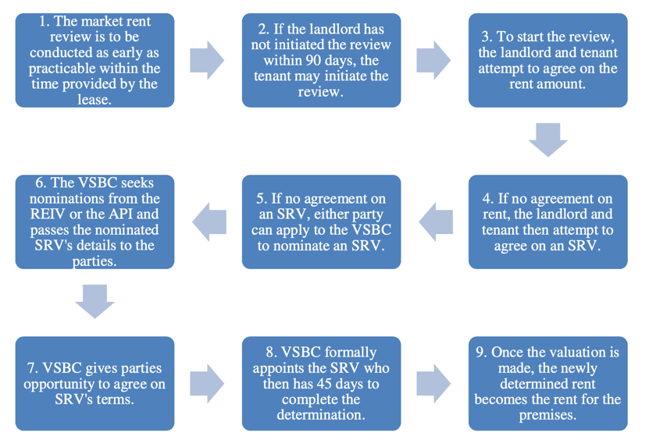
How to resolve a dispute
The VSBC offers a dispute resolution service to assist parties to resolve business disputes. A dispute can be referred to the VSBC by submitting an application which summarises the issues and the parties involved.
The Commission appoints an officer to consider the application, contact the parties and, through preliminary assistance, seeks to resolve the dispute. There is no cost to the parties for this service. If the dispute cannot be resolved at this stage, the parties are invited to attend mediation.
Mediation involves a meeting between the parties in dispute and an independent mediator who will attempt to assist the parties to reach an agreement about the dispute. When all parties agree to mediation, the Commission appoints a mediator and the VSBC arranges the date, time and venue. The mediation can be in regional Victoria if it is more convenient for the parties. Mediation is provided at a subsidised cost to the parties and a session usually takes 3-4 hours. Please refer to the VSBC website for current cost details.
The mediation is confidential; however, any settlement agreement may be taken to VCAT or an appropriate Court for enforcement, if necessary.
Each party pays their own costs at VCAT. However, where a party refuses to take part in mediation, VCAT has the power to order that party to pay the costs of the other party.
Further information including the cost of mediation can be found on the VSBC’s website at www.vsbc.vic.gov.au.
For further information contact the VSBC
Level 2, 121 Exhibition Street Melbourne Victoria 3000
GPO Box 4509 Melbourne Victoria 3001
Telephone 1800 878 964
enquiries@vsbc.vic.gov.au
www.vsbc.vic.gov.au
DOC: 11/18198

