Reducing your energy bills as a small business

Energy costs are a major business input for many small businesses, and with rising energy prices, it is important that businesses explore potential ways to reduce these costs.

While the energy market and pricing arrangements can seem confusing, some basic information is available on ways to reduce overall energy costs. You can start by finding the best retail offers and exploring ways to reduce energy usage.

Finding the best offers
One of the best ways to reduce your energy bills is to shop around for the best offer that meets your needs. There are a number of pricing options and plans available that can help you save money. Victorian Energy Compare is an independent and easy-to-use tool that helps you find the best electricity and gas offers for your small business, based on information you provide about your small business' energy consumption.
The website only takes a few minutes to use and just requires a recent energy bill and information about your business's energy consumption. Users looking to compare electricity plans can also upload their smart meter electricity data to the Victorian Energy Comparator, to get a faster, more accurate comparison.

Reducing energy usage
If your business spends $20,000 a year on energy, you might be eligible for an energy assessment grant through Sustainability Victoria.
The grant provides matched funding for an energy assessment to identify potential energy efficiency improvements for your business, review pricing tariffs and suitable renewable energy options.

Upgrade to energy efficient products

Businesses can access discounts on energy-efficient products and services through the Victorian Energy Upgrades program includes upgrading inefficient lighting as well as motors, refrigeration fans, refrigerated display cabinets and water-efficient spray valves.

Complaints against energy companies

The Energy and Water Ombudsman Victoria can help to resolve most disputes between customers and electricity, gas and water companies in Victoria. It can also take complaints from people who aren't customers of the company but are directly affected by its actions.
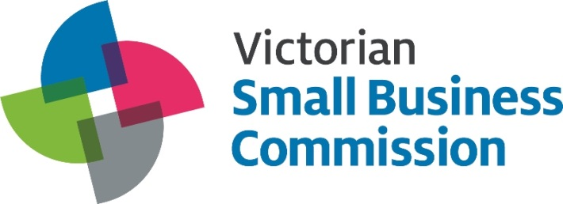
For further information about the VSBC:
T 13 VSBC
E enquiries@vsbc.vic.gov.au
W vsbc.vic.gov.au

